Autism Digital Assistant
Software Requirements Specification

Version 0.91

Revision History

Version | Date | Author | Authorized by | Date
0.90 | 11/Dec/2006 | Huang Donghao
0.91 | 02/Feb/2007 | Huang Donghao

Table of Contents
1. Introduction 4
1.1 Purpose 4
1.2 Scope 4
1.3 Definition of Terms 4
1.4 References 4
2. Overall Description 5
2.1 Product Features 5
2.2 User Classes and Characteristics 5
2.3 Operating Environment 5
2.4 Assumptions and Dependencies 5
3. Functional Requirements 6
3.1 Symbol Library 6
3.2 Schedule 7
3.2.1 Reward 9
3.3 Task Organizers 10
3.4 Communicator 10
3.5 Timer 12
3.6 Money Calculator 13
4. External Interfaces 14
4.1 User Interfaces 14
4.2 Hardware Interfaces 14
4.3 Software Interfaces 14
5. Glossary 15

Table of Figures
Figure 1: Sample PECS Symbols 6
Figure 2: Sample Paper-based Schedule with a Choice 7
Figure 3: Sample Paper-based Schedule and Mini-Schedules 8
Figure 4: Sample Paper-based “Now/Then” Board 8
Figure 5: Sample Paper-based Task Organizer 10
Figure 6: Suggested GUI of PDA-based Communicator 11
Figure 7: Picture of Time Timer 12

Software Requirements Specification

Introduction
The St Andrew's Autism Centre (SAAC) requires the development of the Autism Digital Assistant (ADA) project. The purpose of the ADA project is to use Personal Digital Assistants (PDAs) to assist people diagnosed with autism in learning environments and real life situations.

Purpose
The purpose of this document is to describe the software requirements for the ADA project.

Scope
The ADA project consists of the two kinds of software programs:
- PC program which runs in a PC
- PDA program which runs in a PDA
This document covers the requirements for both kinds of software programs.

Definition of Terms
The following terms have special meanings within this document.
- The word “shall” implies a mandatory requirement.
- The word “should” implies a desirable requirement.
- The word “will” implies a mandatory requirement outside the scope of this document.
- The word “may” implies a desirable requirement outside the scope of this document.
- A glossary of terms used in the ADA project is given at the end of this document.

References
- http://www.sesa.org/wp-content/uploads/2006/10/visualstrat.pdf
- http://www.talklc.com/handout/Visually_Cued_Instruction.html
- http://trainland.tripod.com/pecs.htm
- http://www.autismuk.com/index%20timer.htm
- http://www.gusinc.com/pocketcomm.html

Overall Description

Product Features
In order to assist people diagnosed with autism in learning environments and real life situations, the ADA project shall have the following features, details of which are described in section 3:
- Use a combination of picture, word and sound for user interaction
- Help autistic people organize their class/daily activities
- Help autistic people to communicate with others
- Help autistic people to better handle the time and money

User Classes and Characteristics
The software shall be used by the following two classes of users:
- People with Autism
They shall mainly use the PDA program for class activities, communication, etc. If they are literate and mature, they may also use the PC program to customize his/her PDA program.
- Care Givers
The care givers include special school teachers and parents of the autistic people. They shall mainly use the PC program to help people with autism to make better use of PDA program. For example, a school teacher may use the PC program to create a daily schedule and download it to the PDAs of the autistic students. Parents may use the PC program to help autistic child to customize his/her communicator. The care givers may also be involved in the use of PDA program. For example, in the classroom, for a naughty student to terminate an activity in a schedule, the program may require to enter a password which is only known to the teachers.

Operating Environment
The PC program shall operate on PCs running Windows 2000 or Windows XP. The PDA program shall operate on Pocket PCs running Windows Mobile 5.0.

Assumptions and Dependencies
For better voice effects and efficient usages of the software, a speech synthesizer may be used in the PDA program. The following speech synthesizers are under consideration:
- Digital Future’s Text-to-Speech SDK for Windows Mobile (commercial)
- Carnegie Mellon University’s Flite Speech Synthesis Engine (free)

Functional Requirements

Symbol Library
Since most autistic people think visually, symbols are widely used in ADA. See Figure 1: Sample PECS Symbols (downloaded from http://trainland.tripod.com/pecs.htm).
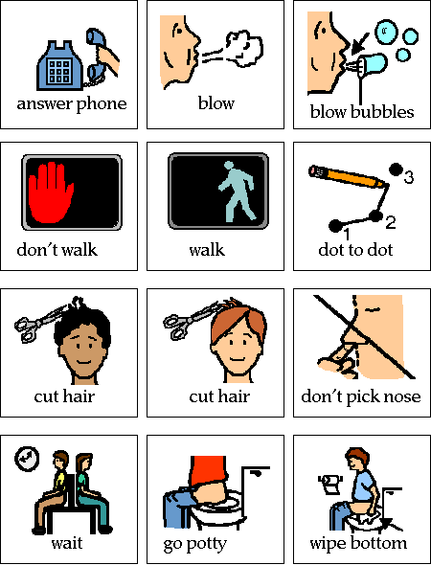
Figure 1: Sample PECS Symbols
The following features shall be implemented:
- Each symbol is matched to the word of the symbol (This encourages the development of literacy skills, and it may be possible to eventually use words instead of symbols).
- Optionally, a symbol may be matched to a sound. E.g. warnings, exclamation, alarm, notification.
- The symbols are organized by categories. E.g. foods, drinks, outings, school activities, school subjects, family members, classmates, feelings, clothing items, descriptive words.
- Each category is also represented by a combination of a picture, a word and an optional sound.
- Vocabulary items within each category are organized alphabetically.
- The symbol shall be organized in PC program and downloaded to PDA program.
- Symbols in the software currently used in SAAC shall be able to be imported.

Schedule
Activity schedules enable children with autism to accomplish activities with greatly reduced adult supervision. An activity schedule is a set of pictures or words that cues a child to engage in a sequence of activities. When the activities are mastered, the children are more self directed and purposeful in their home, school and leisure activities. The schedule helps the student know where to go, when to go, and what is going to happen next. This is one of the most important methods of reducing anxiety for people with autism.
Below are paper-based examples (from http://www.sesa.org/wp-content/uploads/2006/10/visualstrat.pdf):
- Figure 2: Sample Paper-based Schedule with a Choice
- Figure 3: Sample Paper-based Schedule and Mini-Schedules
- Figure 4: Sample Paper-based “Now/Then” Board
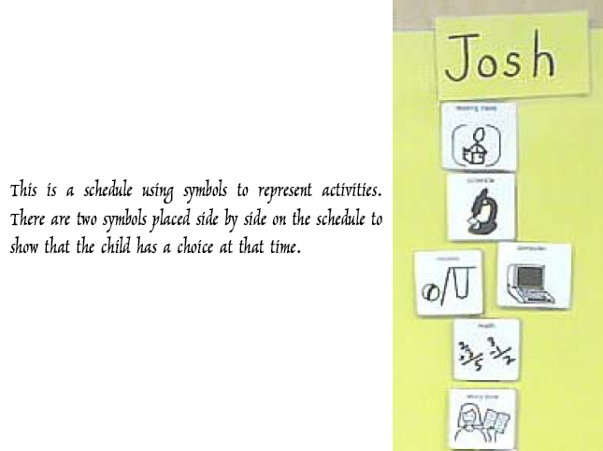
Figure 2: Sample Paper-based Schedule with a Choice
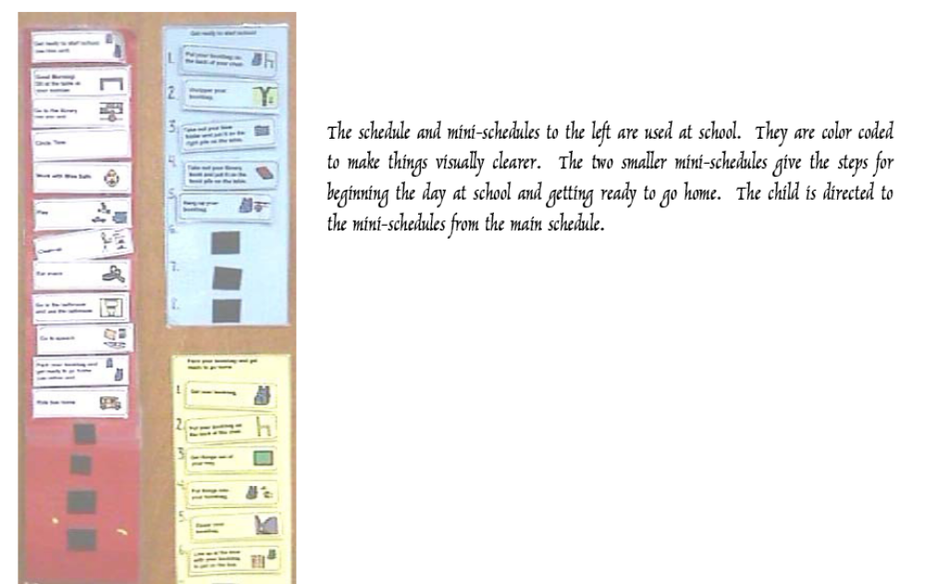
Figure 3: Sample Paper-based Schedule and Mini-Schedules
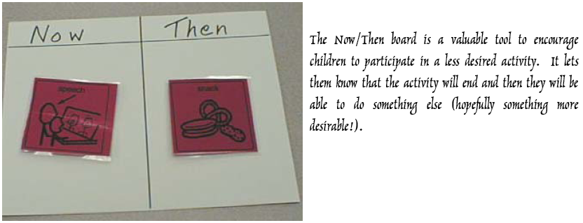
Figure 4: Sample Paper-based “Now/Then” Board
The following features shall be implemented:
- A schedule consists of sequential activities.
- An activity is represented by a symbol, an optional time stamp, and an optional text description.
- At one time, normally there is one activity; if there are more than one activity, the user must make a single choice at that time. Figure 2 shows a sample paper-based schedule with a choice.
- An activity can be further broken down to a mini-schedule which consists of detailed steps of that activity. Figure 3 shows a sample paper-based schedule and mini-schedules used at school.
- An activity can be linked to:
  - A task organizer (see section 3.3)
  - A timer (see section 3.5).
  - Score points (see 3.2.1)
  - A reminder: subset of symbols which are relevant in the activity, e.g. No Running, No Fighting
- The schedule shall be created in PC program and downloaded to PDA program for execution.
- During the execution of a schedule, the student can only start the current activity.
- After an activity is started,
  - If a timer is linked to this activity, the timer is also started
  - If a task organizer is linked to this activity, the task organizer is also started
  - The user can see either current activity alone or both current and next activities or current activity and the related reward game in a “Now/Then” screen (see Figure 4)
  - The user shall be able to switch easily between the current activity, First/Then screen, the timer and the task organizer.
- To terminate an activity,
  - If the student is naughty, the activity can only be terminated by the teacher who is identified by inputting a password;
  - Otherwise, the activity can be terminated by the student.
- After the activity is terminated,
  - If the activity is linked to a reward game, the game shall be started automatically; the game shall be terminated automatically after the specified time has been elapsed.
  - The screen for current activity disappears and the screen for the next activity shall be shown.
  - If all the activities in a mini-schedule are terminated, the parent activity in the main schedule is terminated automatically.
- An activity may have pre-defined start/end time, in which case it can be started / terminated automatically.

Reward
The reward is used to motivate the students with autism. An activity can be attached with score points. Care giver can set the rules such as 10 points → 1 star, 1stars → 1 reward. The reward may be an associated small game and the student may play the game when he/she gets enough scores/stars. Or a student presents the accumulated score points & stars to the care giver to claim the reward he/she desires.

Task Organizers
The use of task organizers helps autistic children who may be unsure of the steps of an activity. Task organizers are visual cues that show the steps of an activity. They provide a visual representation of each part of a task so a child always knows the next step. Pictures and/or written instructions (similar to a recipe) can be used to help children complete the sequence of a task in the right order. Figure 5 shows a sample paper-based task organizer (from http://www.sesa.org/wp-content/uploads/2006/10/visualstrat.pdf).
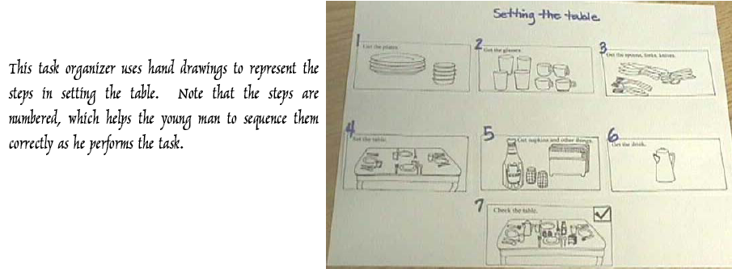
Figure 5: Sample Paper-based Task Organizer
The following features shall be implemented:
- A task organizer consists of sequential task steps.
- A task step is represented by a number, a symbol, an optional time stamp, and an optional text description.
- The task organizer shall be created in PC program and downloaded to PDA program for execution.
- During the execution of a task organizer, the student can only start the current task step.
- After a task step is started, the user can see only current task step.
- After the task step is terminated, the screen for current task step disappears and the screen for the next task step shall be shown.

Communicator
The use of communicator helps autistic people to communicate with others. The following features shall be implemented:
- The main graphic user interface (GUI) of the communicator should be similar to what is shown Figure 6 (from http://www.gusinc.com/pocketcomm.html):
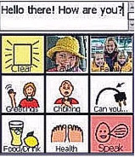
Figure 6: Suggested GUI of PDA-based Communicator
- The user makes use of the buttons in the GUI to form one or more sentences
- Each button can be associated with a symbol which is selected from the Symbol Library as described in section 3.1.
- A Text Button represents a text, i.e., a phrase or a sentence, e.g. I want…, apple, fruit, “My name is Alice.” etc.
- Text Buttons are organized into scenarios:
  - A scenario defines the context in which the communication happens, e.g., in the restaurant, in the classroom, meeting a new friend, etc.
  - A scenario contains multiple Text Buttons
  - A scenario is also represented by a button
- Organization of Text Buttons and Scenario Buttons shall be defined in PC program and downloaded to PDA program.
- When the button “Clear” is pressed, the content of the text box is cleared
- When the button “Speak” is pressed, the content of the text box is spoken in voice.
- When a button other than “Clear” or “Speak” is pressed,
  - If it represent a scenario, the symbols contained in the scenario is shown
  - If it does not represent a text, its associated text is inserted into the text box
- The content of the edit box can be stored into a favorite list so that it can be retrieved easily for later conversation.
Sample symbols in the scenario “Meeting New Friends”:
- Hello
- My name is Alice
- How do you do?
- Nice to meet you
- Keep in touch
- Good bye!
Sample sentences in the favorite list of the scenario “In the Restaurant”:
- Please get the waiter.
- May we have more bread please?
- Could I have the menu?
- Could I have the bill please?
- This food is too cold.

Timer
The Time Timer (http://www.autismuk.com/index%20timer.htm) is an innovative new teaching aid aimed toward time education for both young children and those with special needs. The abstract concept of time is easy to see and understand with the Time Timer’s visual depiction of elapsed time. See and “feel” time elapse as the red dial gets smaller and smaller each minute. No need to be distracted by the hands and the numbers of a traditional clock face. The Time Timer clearly shows you how much time is left in any interval of 60 minutes.

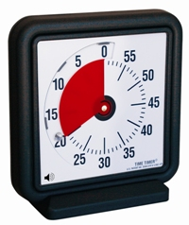
Figure 7: Picture of Time Timer
The ADA Timer is a virtual timer which runs in PDA program. The following features shall be implemented:
- The GUI of a time should simulate the user interface shown in Figure 7: Picture of Time Timer.
- The use inputs the desired time interval (in minutes) by entering a number between 1 and 60, and then the red disc will change its size accordingly.
- When the timer is started, the red disc diminishes as time elapses until no red is visible on the timer.
- When the time is up, the pre-defined alarm sound which will be played

Money Calculator
The Money Calculator helps autistic people to deal with money. The following features shall be implemented:
- Symbols are used to represent different kinds of notes and coins
- When a required money amount is input, the suggested notes are blinking
- When user selects one note or coin, if the total amount is still under the required amount, the software will prompt another suggestion by blinking the correct notes or coins.
- When the total amount is equal to or bigger than the required amount, the system will not blink any notes or coins. It shall display the amount of change to be collected.

External Interfaces

User Interfaces
The system should provide friendly user interface for user’s operation. The SAAC will validate the user interface design and give some advice to the designer from the user’s perspective. The user interface shall be refined or modified according to the field test results from SAAC.
The ADA shall provide user interfaces in English languages. The software should be designed so that the user interfaces in Simplified Chinese language may be easily implemented in future.

Hardware Interfaces
The PDA and the PC shall be connected using the USB cable or cradle which shall be provided in the purchased Pocket PC package. The PDA program and PC program shall communicate with each other using this hardware interface. No other hardware interfaces are planned.

Software Interfaces
No special software interfaces are planned.

Glossary
Item | Description
Graphical User Interface (GUI) | See http://en.wikipedia.org/wiki/Graphical_user_interface
Personal Digital Assistant (PDA) | See http://en.wikipedia.org/wiki/Personal_Digital_Assistant
Picture Exchange Communication System (PECS) | See http://en.wikipedia.org/wiki/PECS
Pocket PC | See http://en.wikipedia.org/wiki/Pocket_PC
Speech Synthesis | See http://en.wikipedia.org/wiki/Speech_synthesis

